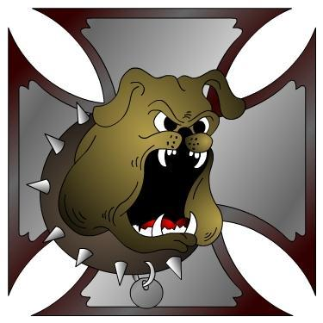
DOGGs
Is a group of Dallas Oregon Old Guys and Gals that are interested in wholesome motorcycle fun. Don't let our name fool you, we are made up of a variety of ages and bikes. We meet the first Tuesday each month at 7:00PM at The Grain Station, 220 Pacific Av S, Monmouth, Oregon.
https://www.facebook.com/groups/doggs.members/
Apr 7; DOGGs Meeting.
Apr 3-5 ; PIR Swapmeet.
Apr 19; DOGGs 15th Anniversary Ride and Silent Auction.
Apr 23-25 ; Laughlin River Run. Maybe??
Apr 25-26 ; ABATE Swap Meet, Pottsville. 9-5.
May 2: Motorcycle Awareness Rally, State Capital, 11am Kmart lot.
May 5; DOGGs Meeting.
May 10; DOGGs Sunday Ride.
May 16 : Salem HD Swap Meet.
May 17; OVM Swapmeet and Bike Show, Corvallis.
May 19; Dinner social/DOGG Chow.
May 22-25; Fossil Campout.
May 23; Sweeneys 6th annual Poker Run?
May 25; Memorial Day.
May 30-31; Overniter! Redmond? Coos? Gold Beach? Klamath?
Jun 5-7; Spring Street Vibrations. Reno, Nevada.
Jun ; Joker Poker, Strip Poker Run. Portland.
Jun ; Hub City ABATE Poker Run. Albany.
Jun 2; DOGGs Meeting.
Jun 7; DOGGs Sunday Ride.
Jun 12-13; Redwood Run. Garberville, Ca.
Jun 12-14; 3 Day Run! Silver Lake?
Jun 16; Dinner social/DOGG Chow.
Jun 19-20; 6th annual Wallowa Run. Joseph, Oregon.
Jun 19-21; Shovelfest-West Campout. O’Brian.
Jul 5; Sunday Ride and BBQ
Jul 7; DOGGs Meeting.
Jul 9-13; Hells Canyon Rally, Baker City, Or.
Jul 9-25 ; Jim’s ‘Where ever the hell I wanna go’ Run!
Jul 10-12; 3 day’r? Eastern Oregon? Mt St. Helen’s?
Jul 13-19; Pendleton Bike Week.
Jul 17-19 ; Run 21, Otis.
Jul 21; Dinner social/DOGG Chow.
Jul ; Salem HOG, Rally in the Valley.
Aug 7-16; Sturgis
Aug 4; DOGGs Meeting.
Aug 7-10; 3 DOGG-Niter!
Aug 18; Dinner Ride.
Sep 1; DOGGs Meeting.
Sep 4-6; End of Summer 2-niter?
Sep 15; Dinner Social/DOGG Chow.
Sep 27; Anacortes, Wa Oyster Run.
Sep 24-27; Street Vibrations, Reno, Nevada
Ride Safe and have fun!! EEEEHAAAA!!!!
